Assignment 19
RADIUS & TACACS+ (Section 2)

Shreya Panchal
Topic: RADIUS and TACACS+ Key Features, RADIUS Authentication Process, Failure Scenarios, Router Configurations

Theory Overview

1. Architectural Differences
RADIUS and TACACS+ are both AAA protocols, but they serve fundamentally different purposes in enterprise security architecture. RADIUS combines Authentication and Authorization into a single phase to optimize speed for user access networks, whereas TACACS+ completely separates all three components (Authentication, Authorization, and Accounting) to provide meticulous control over device management.

2. Encryption Protocols
RADIUS Security: Only encrypts the password string within the access packets using an MD5-based pre-shared key hashing method. The remaining headers (like usernames, accounting stats, and device attributes) are sent in clear text.
TACACS+ Security: Uses a modern architecture that fully encrypts the entire body of every packet exchanged between the network access device and the server, protecting sensitive operations and device topology from packet-sniffing tools.

Tasks & Answers

Task 1: RADIUS vs. TACACS+ Features Comparison Table
Question: Create a comparison table listing at least 4 key features of RADIUS and TACACS+ side by side, highlighting which protocol supports each feature.
Answer:
Key Feature | RADIUS Support | TACACS+ Support
Transport Layer & Port | Uses UDP (Ports 1812 / 1813) — optimized for fast, multi-user transaction spikes. | Uses TCP (Port 49) — guarantees packet delivery and session connection checks.
Data Body Encryption | No. Encrypts only the password fields inside packets. | Yes. Encrypts the entire network packet payload seamlessly.
Separation of AAA Functions | No. Combines Authentication and Authorization tasks into one packet sequence. | Yes. Fully separates Authentication, Authorization, and Accounting.
Granular Command Authorization | No. Cannot authorize individual terminal configuration keywords. | Yes. Can intercept and authorize every single CLI command live on a device.

Task 2: Step-by-Step RADIUS Wi-Fi Hotspot Authentication Flow
Question: Draw a step-by-step flow diagram showing the RADIUS authentication process for a user logging in to a public WiFi hotspot, labeling each communication step between the client, network device, and RADIUS server.
Answer:
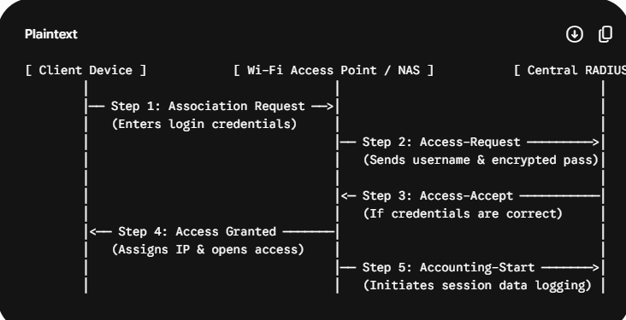

Task 3: Real-World Use Cases: Why TACACS+ is Preferred Over RADIUS
Question: List 3 real-world use cases where TACACS+ is preferred over RADIUS, and briefly explain why TACACS+ is better suited for each scenario.
Answer:
Core Enterprise Router Administration: When managing network backbone devices, administrators type powerful commands that can drop global data lines. TACACS+ is preferred because it can validate individual input patterns (like blocking reload) before executing them on a device.
Highly Audited Compliance Environments (Banking/FinTech Systems): Financial companies must document exactly who changed a network route or security setting. TACACS+ accounting records the exact string typed by an individual engineer, creating an immutable audit trail.
Privileged Internal System Configuration Changes: If an enterprise separates its network engineers into Tiers (Tier 1 vs. Tier 3), TACACS+ can check the specific permission level of a tech dynamically, adjusting their shell capabilities during an active SSH session.

Task 4: Authentication Failure Handling: RADIUS vs. TACACS+
Question: Given a scenario where a user tries to log into a network device but fails authentication, describe how RADIUS and TACACS+ would handle the logging and response differently. Hint: Focus on how each protocol manages accounting and command authorization.
Answer:
RADIUS Behavior on Failure: When authentication fails, the RADIUS server immediately drops the connection by transmitting an Access-Reject packet back to the network switch. Because RADIUS bundles authorization with authentication, the network interface closes completely. No accounting entry or session parameters are tracked because a valid session was never created.
TACACS+ Behavior on Failure: In contrast, because TACACS+ decouples its structural modules, an authentication failure triggers a discrete FAIL status response back over the established TCP stream. The system generates a timestamped accounting record noting the unsuccessful attempt, logging the targeted device interface and username. Furthermore, because its command authorization module functions independently, the router blocks the user from typing any operational configuration keywords while maintaining a clean diagnostic connection log.

Task 5: Basic RADIUS Configuration & College Setup Modifications
Question: Use ChatGPT or another AI tool to generate a sample RADIUS configuration snippet for a Cisco router, then review the output and list any changes you would make to adapt it for a college campus WiFi setup.
Answer:

Generated Basic Configuration
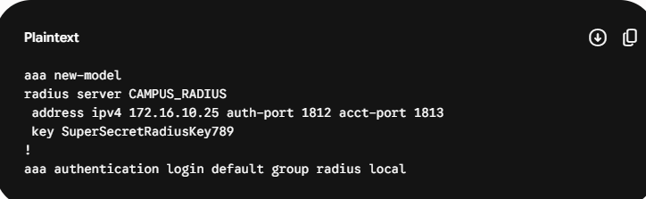

Modifications for a College Campus Wi-Fi Setup
